=====================================================================================

SET 2

Q1. (Algorithms – 5 Marks)
Using AI assistance, generate Python code to implement Merge Sort.
Run the algorithm on the list: 45, 12, 3, 67, 34, 21.
Explain the time complexity and how AI improved correctness.
PROMPT: GENERATE A PYTHON CODE TO IMPLEMENT MERGING SORT FOR THE LIST OF [45,12,3,67,34,21]
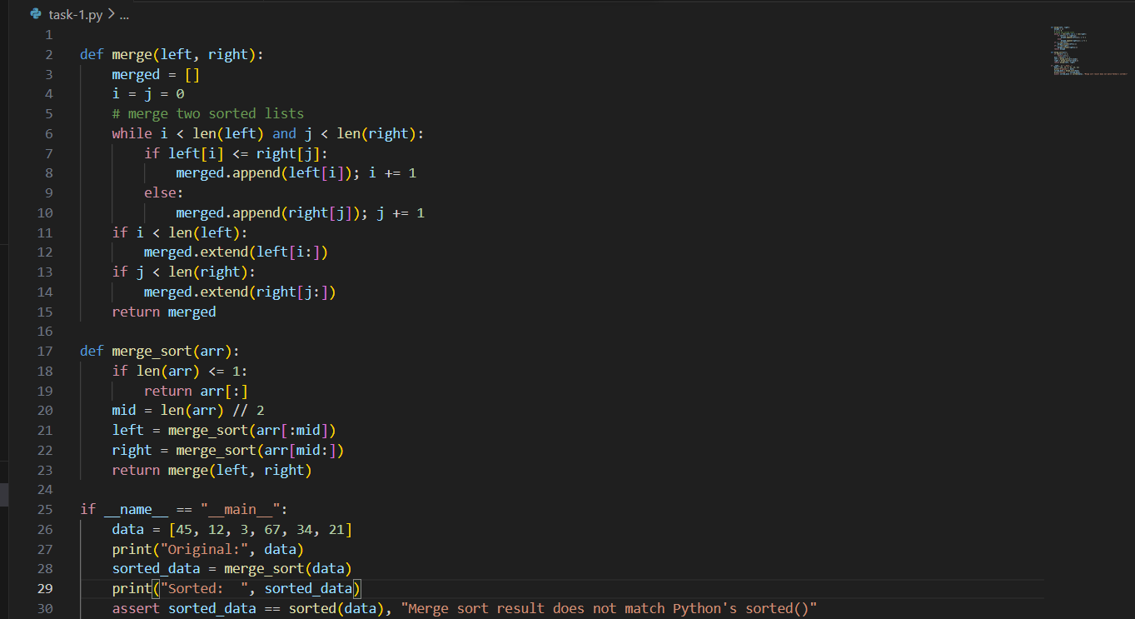
OUTPUT:
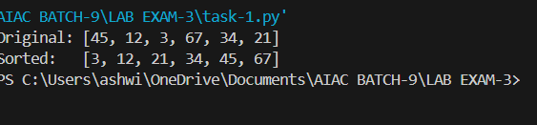

Q2. (Web Frontend – 5 Marks)
Use AI to generate a webpage showing a student registration form with:
- Input fields (Name, Email, Course)
- Submit button
- JavaScript form validation
PROMPT: GENERATE A WEBPAGE USING HTML CSS AND JS OF A STUDENT REGISTRATION FORM THE INPUT SHOULD CONTAIN NAME EMAIL AND COURSES HAVING A SUBMIT BUTTON
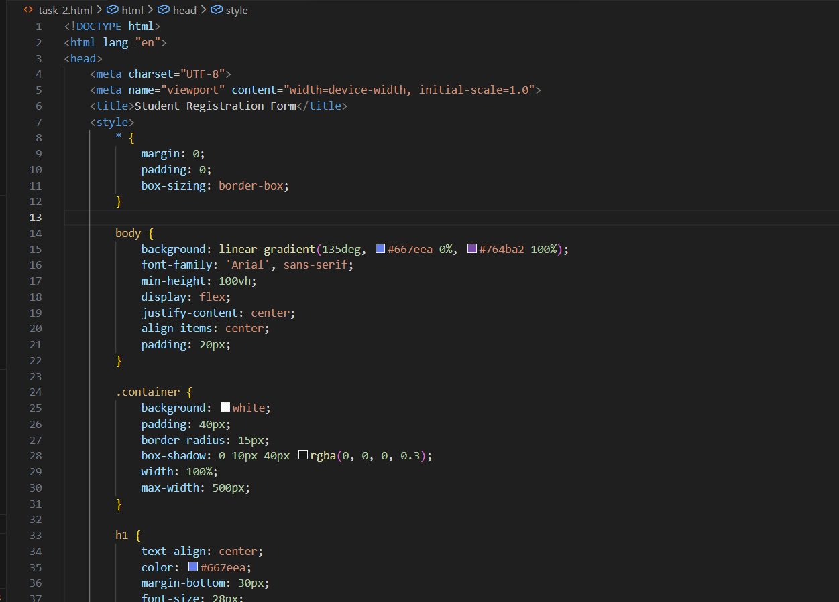
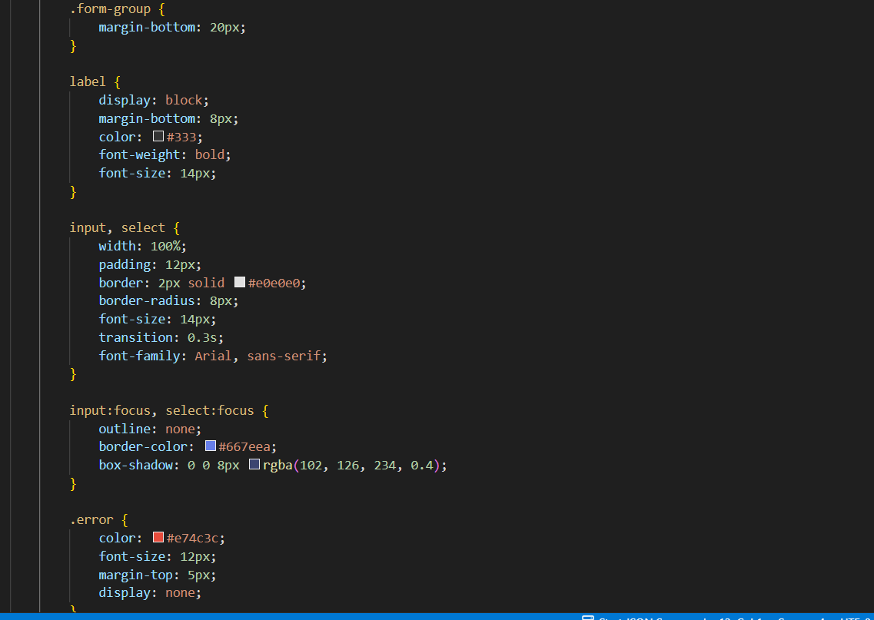
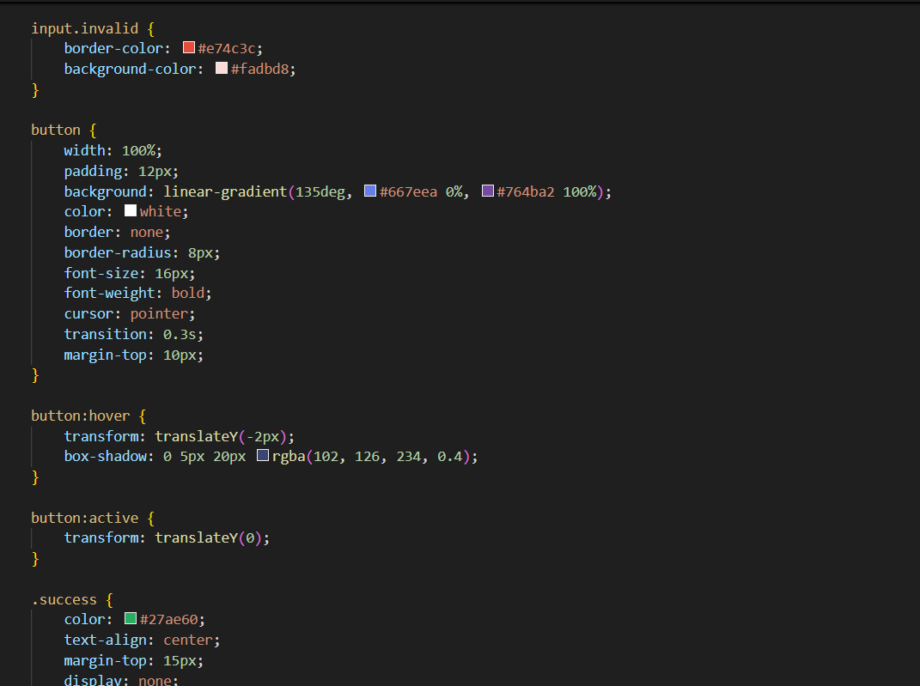
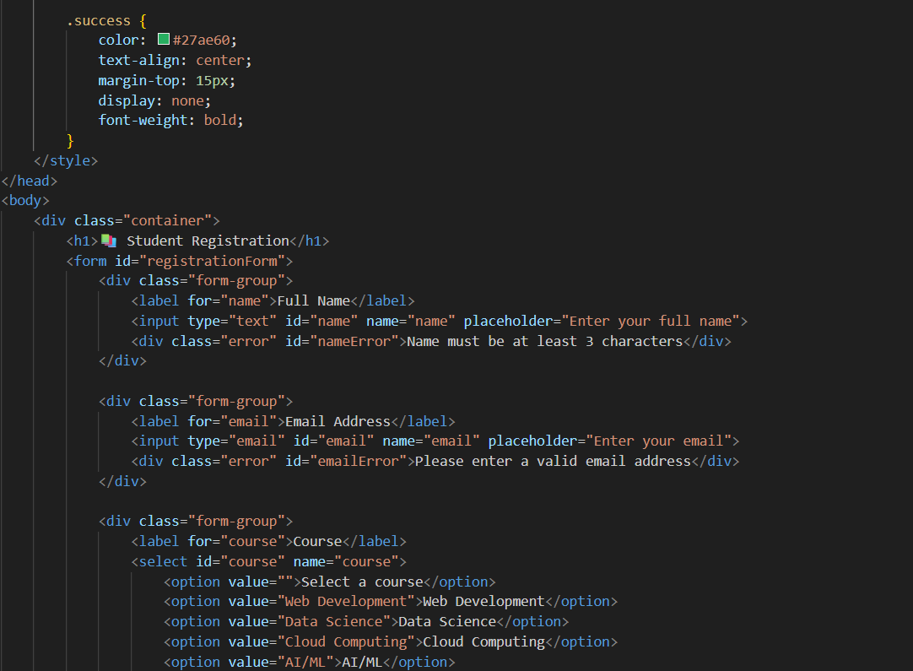
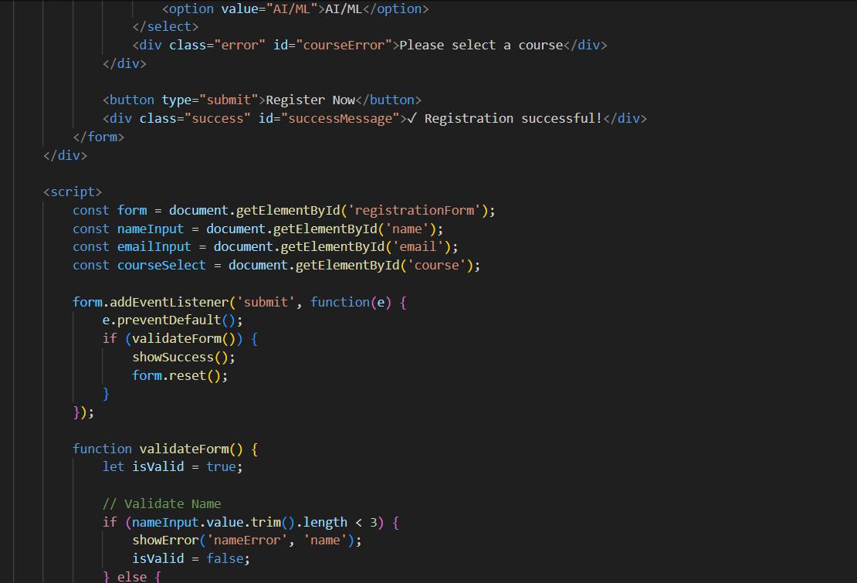
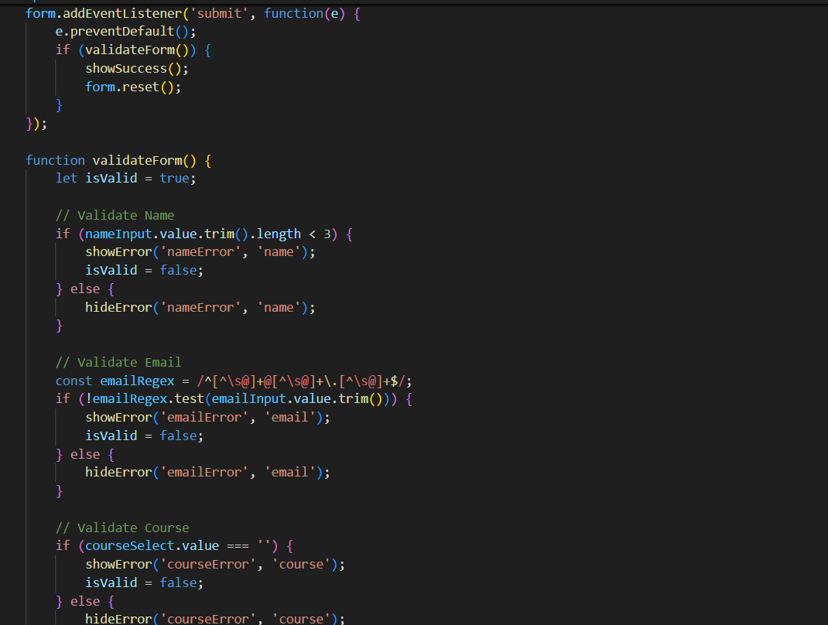
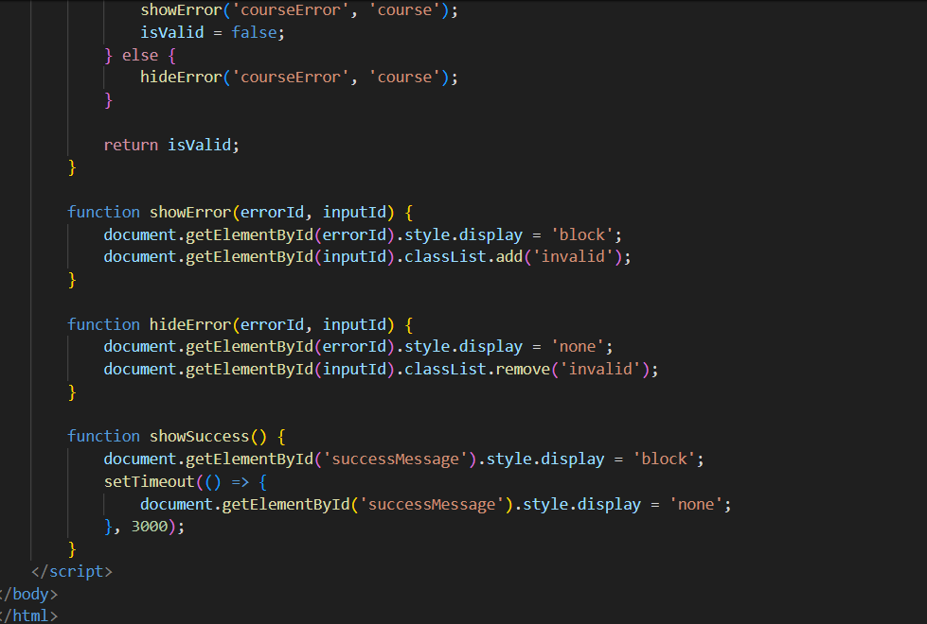
OUTPUT:
